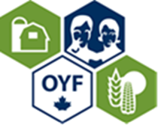
Canada’s Outstanding Young Farmers’ National Event Registration Form
December 5-8, 2019
Fredericton, New Brunswick
Names

Address | City
Province | Postal Code
Business Website | Cell Number
Email | Twitter handle
Alumni(includes immediate family members) YES NO

FULL REGISTRATION INCLUDES ALL MEALS AND EVENTS FROM THURSDAY LUNCH TO SUNDAY BREAKFAST

Saturday Night will be a Lobster Supper. Please indicate your preference LOBSTER ALTERNATE MEAL

Pricing Information | Price | X # of People | Total
Early Registration – Includes full event
Available until August 31, 2019
Register during this time to be eligible for Lobster draw
Alumni: $300 Non Alumni: $500 Children 12 and under $250 (includes children meal options not regular menu)
Please choose Thursday Tour option 1 or Tour Option 2 see attached schedule
Registration –Includes full event
(received until October 15th, 2019)
Alumni: $450 Non Alumni: $550 Children 12 and under $250
Friday DAY only: Forum/Lunch/Honoree Presentation
Adult $60 Student(ages 13-22)/Children $30
Friday Gala Banquet Only
Adult $120 Student $60 (ages 13-22) Children 12+under $30.00 (kids meal option not plated meal)
Friday Event Forum/Presentations/Gala includes 3 meals
Adult $180 Student (ages 13-22) $125 Children 12 + under $75
Saturday Only Tour & 3 meals
Adult $160 Children 12+under $100
Sub Total
Add 15% HST
Total #1
THERE WILL BE NO REFUNDS FOR CANCELLATIONS AFTER November 1st, 2019

COYF Memorial Scholarship Fundraiser
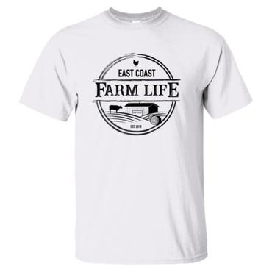 |  | This year as a way to raise funds for the scholarship we are selling these OYF clothing options. They are made in Nova Scotia and have the COYF Logo on the top centre back. You can preorder and pick your color and size. Items will be ready when you pick up your registration package. $10 from the sale of each item will go towards the scholarship. T-shirts are $33.00, Hoodies are $56.00, Long sleeve shirt $36.00. Items can be viewed at www.eastcoastfarmlife.ca (we will be placing orders through our local contact for COYF discount)  Available colors are :Black, Maroon, Grey, Red, Pink, White, Purple  Available sizes are: Small - XXXL
T-shirt/ Long sleeve/Hoodie | Size | Color | Cost
Example: Long Sleeve | Medium | Maroon | $36.00
Total #2
GRAND TOTAL (Total #1 + Total #2)
FOOD ALLERGIES- Please list

Travel Information: Please provide updates if your travel information changes prior to the event
Arrival Date | Time of Arrival | Airline | Flight#
Departure Date | Time of Departure | Airline | Flight#
If you are DRIVING YES NO
Accommodations are booked at Delta Hotels by Marriott Fredericton. To make your reservation Please call 1-888-236-2427 and use Group Code FAR or click on the following link; https://www.marriott.com/events/start.mi?id=1545245198488&key=GRP
Please make reservations before October 31st
Rooms $149+ tax per night. Complimentary parking. Identify yourself as being with Canada’s Outstanding Young Farmers PLEASE MAKE HOTEL RESERVATIONS EARLY!

SEND COMPLETED REGISTRATION FORMS AND CHEQUE PAYMENT TO:
Carla Kaeding Box 229 Churchbridge, SK S0A 0M0 Email kaedingc@hotmail.com
Please make cheques payable to: Atlantic Outstanding Young Farmers

This year we will be offering E-transfer option. E-transfers can be sent to coyffredericton2019@gmail.com. No security question or password required.

