Email Subject: Join us at the Agricultural Excellence Conference!

As a Supporting Partner for the 2019 Agricultural Excellence Conference, COYF encourages you to attend this great event! If you’re coming to the COYF National Event, come early to join fellow farm management enthusiasts this December 2-4 in Fredericton for learning and networking. Make a week of it- 2 great events, 1 week!

Cultivating Resilience
December 2-4, 2019 | Fredericton, New Brunswick
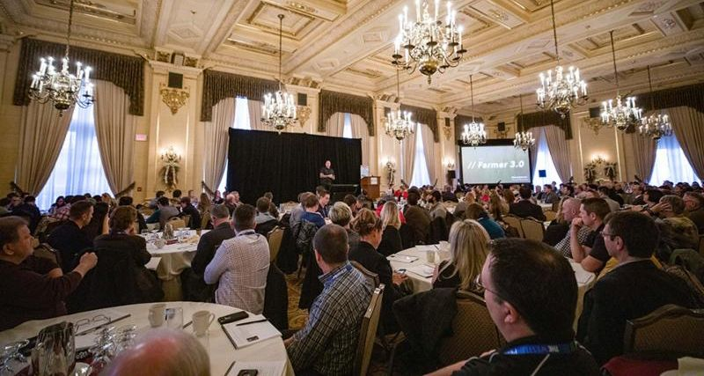

The Agricultural Excellence Conference is a one-of-a-kind event that brings diverse industry experts and stakeholders together from across disciplines, regions and production sectors to share and explore beneficial farm management practices and insights with leading farm business thinkers. Build your network of fellow farm management enthusiasts!

The theme Cultivating Resilience focuses on building the capacity for you and your farm to weather any storm and seize opportunity. A healthy farm depends on a healthy farmer, healthy relationships and healthy business. We will discuss the future of Canadian agriculture, the implications for farm managers, and the practical ways farmers can achieve sustainable growth and prosperity. Conference-goers will come away from AgEx equipped with information and tools to enhance Canada's farm businesses.

Featuring:
- Economic Outlook for Canada’s Farmers
- Management Tactics for Leading Farmers
- Taking Care of Business: You and Your Farm – Facilitated by the Canadian Centre for Occupational Health and Safety
- Building your Peer Advisory Group – Who and How – Terry Betker, Backswath Management Inc
- Bridging the Gap: Family Farm Transition Panel - Moderated by Brent VanParys, BDO
- Secrets to Success: Canada’s Outstanding Young Farmers, Amy Cronin, Cronin Family Farms
- Black Swans – Friend or Foe? – Don Buckingham, Canadian Agri-Food Policy Institute
- What’s their Beef with Beef? – Ellen Crane, Beef Cattle Research Council
- Making the Case for International Collaboration to Improve Skills Training – Gavin Robertson, Garage d’Or Ciders
- Cultivating Innovation through On-Farm Trials – Shelley Spruit, Against the Grain Farms
- Getting Highest Value for your Cash Crop – Josh Oulton, TapRoot Farms Inc.
- Farm Business Management Resource Showcase
- Concurrent Workshops
- and more!

Funding Available for Farmers!
Farming in Manitoba, PEI, New Brunswick, Yukon or Northwest Territories?
You could be eligible for cost-share funding to attend! Check with your Ministry of Agriculture.

For a limited time,
Buy One Get One 50% Off!
This offer is available as an early bird incentive, so don’t delay!
Register now!

For help with your registration, please contact the conference organizer:
Farm Management Canada
Tel: 1-888-232-3262 or (613) 237-9060 | Email: info@fmc-gac.com

For more information, visit www.fmc-gac.com or follow #AgExConf19 on Twitter.

We hope to see you there!

Sincerely,
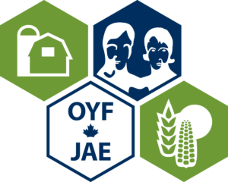Canada’s Outstanding Young Farmers

